**LAPORAN PSEUDOCODE & FLOWCHART**

**DOSEN PENGAMPU Prasetyo Wibowo. S.S.T., M.Kom.**



**WAHYU IKBAL MAULANA - 3323600056**

**POLITEKNIK ELEKTRONIKA NEGERI SURABAYA**

**PRODI SAINS DATA TERAPAN**

**SEPTEMBER 2023**

1. **Create Fibonacci sequence sequence of 0, 1, 1, 2, 3, 5, 8 ...**

Input : number for range stop

Process : x less or equal than 1 return x, if more than 1 calculate fibonacci(x-1) + fibonacci(x-2)

Returns the n Fibonacci number. If n is equal to 0 or 1, then the function

will return the value 0 or 1. If n is greater than 1, then the function will return the

sum of the (n-1) and (n-2) Fibonacci numbers.

Output : DISPLAY fibonacci(x)

**PSEUDOCODE:**

INPUT x

SET range start

SET range stop

FOR i in range:

IF x <= 1:

return x

ELSE:

SET fibo = fibonacci(x-1) + fibonacci(x-2)

APPPEND fibonacci += fibo

DISPLAY fibonacci(x)

END

**FLOWCHART:**

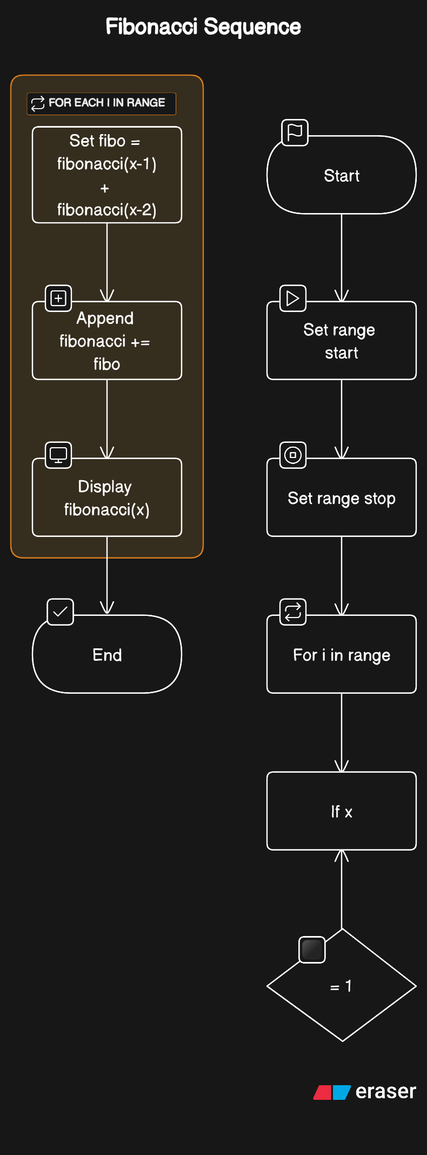

1. **Create Program using LIFO**

Input : nominal uang

Process : make a list and create function for removes list, delete lastest siswa in the list using the get list

Output : display result of removes function

**PSEUDOCODE:**

INPUT uang

SET dompet = []

Add uang = [50.000,20.000,10.000]

Append uang to dompet

Display dompet

REMOVES(dompet):

POP latest element FROM dompet

Display dompet(n-1)

END

**FLOWCHART:**

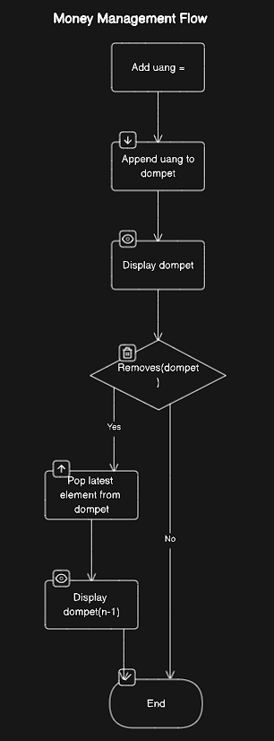

1. **Create Program using FIFO**

Input: siswa

Process: make a list and create function for get list, delete earliest siswa in the list using the get list

Output: display result as get function

**PSEUDOCODE:**

INPUT siswa

SET kelas = []

Add siswa = [bayu,andi,afif,dimas,ricko]

Append siswa to kelas

Display kelas

GET(dompet):

DEQUEUE earliest element FROM kelas

Display kelas(n-1)

END

**FLOWCHART:**

